 | Year 12 Specialist  TEST 2  2018  TIME: 5 mins reading 40 minutes working Classpads allowed!  36 marks 8 Questions

Name:_______________________________

Teacher: ____________________________

Note: All part questions worth more than 2 marks require working to obtain full marks.

Q1 (2 & 2 = 4 marks)
Consider .
- Show that is a factor of

- Determine three linear factors of

Q2 (5 marks)
Consider where are constants. Given that is a factor of and when is divided by has a remainder of . Determine .

Q3 (3 marks)
Given that and . Does exist over the natural domain of ? Explain your answer.

Q4 (2 & 2 = 4 marks)
Given that and :
- Determine the rule of

- State the natural domain and range of

Q5 (3 & 3 = 6 marks)

- On the diagram, sketch the inverse function

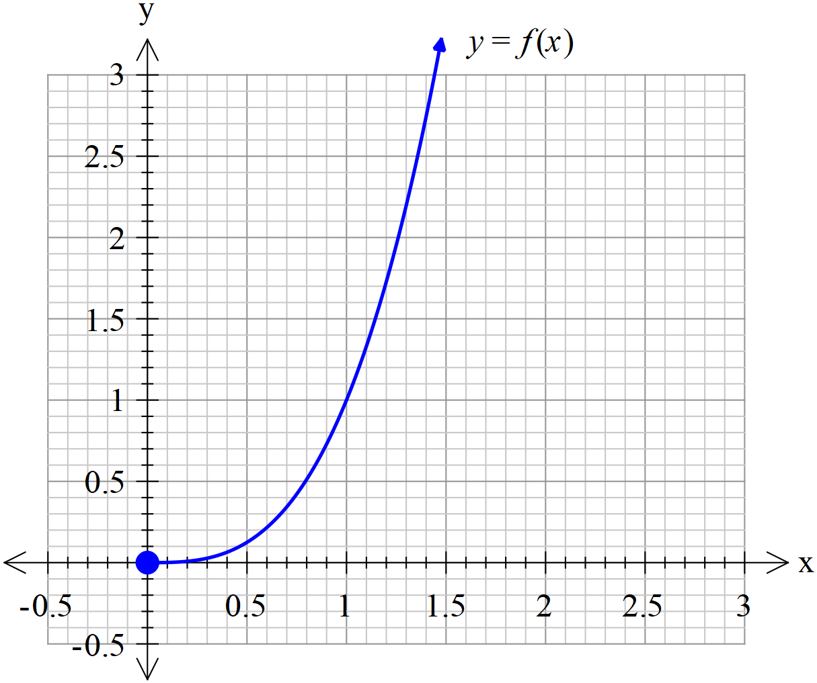

- On the diagram below, sketch



Q6) (1, 1, 2 & 2= 6 marks)
Consider the function where are non-zero constants.
- Determine the natural domain of

- Determine the limit that approaches as

- Determine the inverse function in terms of .

- Determine the possible values of if .

Q7 (4 marks)
Consider the equation which is true and only true for .
Determine the possible values of the constants .

Q8 ( 4 marks)
Let , prove that

